GIT & GitHub

Monday, April 10, 2023

5:40 PM

**GIT: Version control tool which tracks the changes in the files and can maintain the source of all versions.**

**GitHub: It is a cloud based platform which hosts git repositories and it allows all git operations on repo.**

***GIT Commands***:

* git init | to initialize the folder or project as git repository
* git status | to know the status of branch, untracked files and commit
* git add <Filename> | add files to staging area
* git rm --cached <Filename> | removes file from staging area
* git add . | adds all the files to staging area (multiple files)

COMMIT

* git commit -m "commit message" | to commit the staged files to branch
* git log | shows all the commits on the branch
* git log --oneline | shows commit details in one line

UNDOING THINGS

* Checkout commit - to see code in some earlier commit snapshot

git checkout <uniqueId> | goes back to that commit snapshot and its read only can edit files

git checkout <BranchName> | now head points to actual comes back from earlier commit

* Revert commit

git revert <uniqueId> | reverts the earlier commit made (actually deletes that old lines of code on present snapshot)

* Reset commit - complete deletes all the commits and rebases to mentioned commit

git reset <unique Id>

BRANCHES

* git branch <branch name> | creates a branch with name mentioned
* git branch -a | shows list of all branches
* git checkout <branch name> | switches to mentioned branch
* git branch -D <branch name> | deletes the branch
* git checkout -b <branch name> | creates the branch with mentioned name and checkouts to that branch
* git merge <branch name> | merges the changes from feature branch (branch name) to requires branch (we should checkout that branch and do this command)

***GITHUB***:

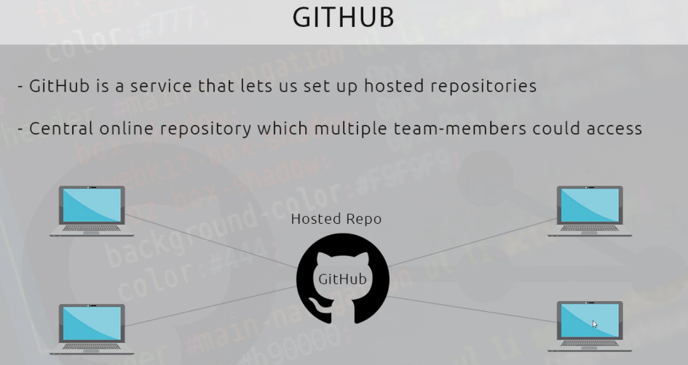

Create repository in github

* git push <repo URL> master | will push the local repo master branch to newly created remote repo
* git remote add origin <repo URL> | giving alias name to remote repo URL here the alias name is origin
* git push origin master | push changes made to remote repo
* git clone <repo URL> | clones remote repo to local
* git remote -v | shows the origin details
* git pull origin master | pull all the changes from remote master to local master branch
* PULL REQUEST
* FORK and PR

Reference: [Git & GitHub Tutorial for Beginners](https://www.youtube.com/playlist?list=PL4cUxeGkcC9goXbgTDQ0n_4TBzOO0ocPR)

